Module 1: Effective Communication

Task 1: Write professional emails based on any 5 of the following scenarios. Ensure clarity, conciseness, and a formal tone.

1. Thank you Email
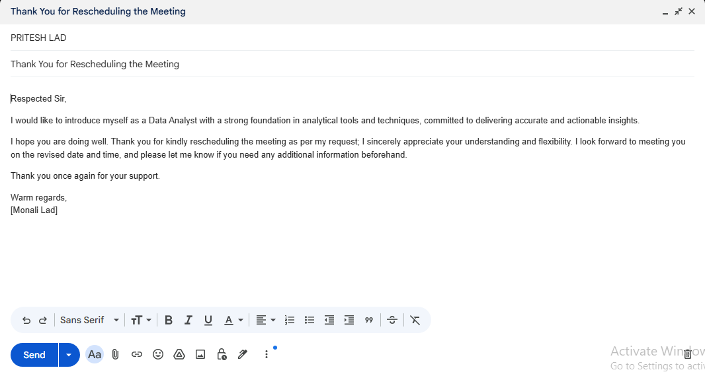

2. Letter of Apology

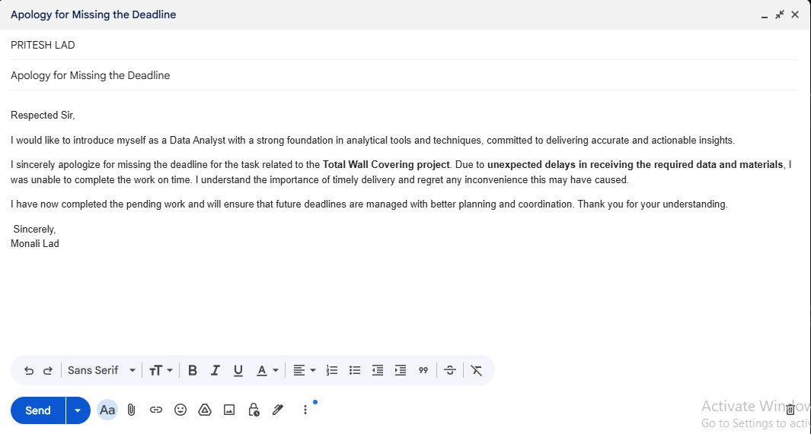

3. Email of Inquiry for Requesting Information

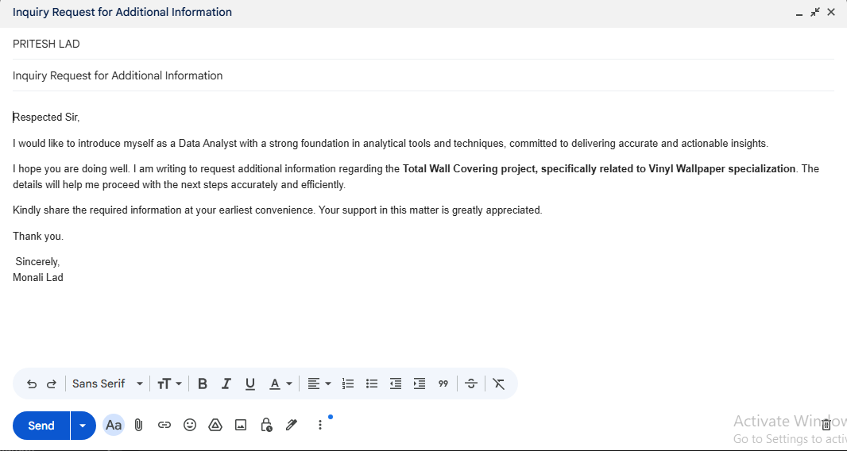

4. Asking for a Raise in Salary

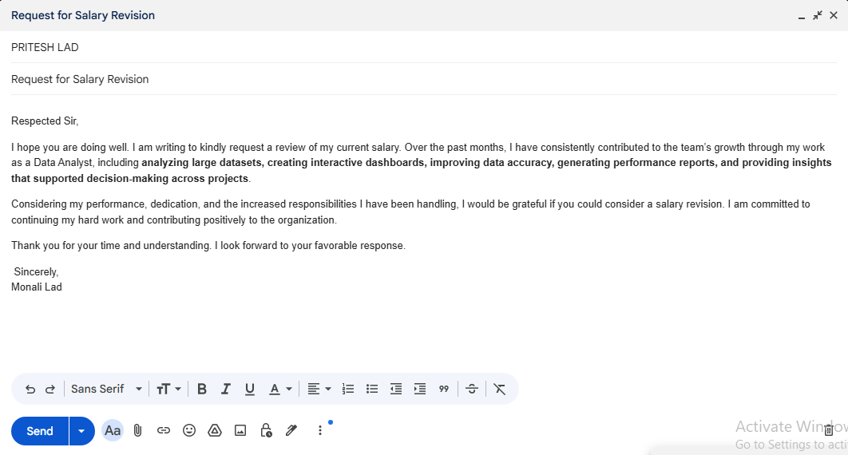

5. Resignation Email

